CHAPTER 01:
INTRODUCTION

1.1 Objective
The Motto behind the share module software is to maintain the records of the shareholders of the co-operative bank and perform the dividend calculations in the back end in better way for the co-operative bank by endorsing the functioning platform of the bank module for dealing with the personal information of the shareholders and getting a fair share of dividend amount in a better and efficient way to each of the shareholders.

1.2 Basic Idea
This technique is more time and cost effective in terms of manpower involved instead of the manual method. This is so because when the work of the co-operative bank is carried out using papers and manual calculations, it requires lots of time to carry out the complete database maintenance and dividend calculations of the co-operative bank manually and it is also very tedious to maintain the record of the earlier transactions of each and every shareholder. As soon as the system is automated and implemented using software, it becomes very easy to maintain the previous sessions by creating a backup. The bank staff can fill up the form for the shareholder’s data entry, and as only the authorised bank personnel is allowed to carry out this process, there is no need for extra supervision on part of the administrator.
Since the software is being developed for the Co-operative Bank, it has to deal with the calculations that are basically handled by the cooperative bank. Dividends are payments made by a bank to its shareholder members. Now these can be illustrated in lucid way with the help of a co-operative bank with five shareholders. Now let us consider that they have invested for building up a cooperative bank. Now at the end of session for which the bank was working has got some profit. Now some of the fund from that profit is declared as Dividend share. For example, if the dividend declared is 10% then the members of the cooperative bank will receive the share according to their investment made by each of the member towards bank activity at the start of the session. Then this information which being compiled by the user to give the better share to the members is being stored in the database.

1
1.3 Platform:
The Share Module is the system which works on the platform of the database storage of the shareholders of the bank and shares which are been allotted to each of the member with help of the calculated or declared dividend in percent. The database is being managed in ORACLE 10g. Here in, the information of the co-operative bank shareholder is being stored, which is further discussed in detail in chapter . The data is stored and retrieved through the front end user interface (UI) provided which has been designed in ORACLE Forms 6i, and discussed in more detail in chapter .........
The forthcoming chapters would explain all the technologies being used in the development of the project along with their implementations.

2
CHAPTER 02:
REVIEW OF LITERATURE

2.1

3
CHAPTER 04:
ORACLE FORMS 6i

4.1 BASIC CONCEPTS
The primary task of a commercial database application developer is to design data-entry forms that look as close to the printed sheets of paper that the data entry operators use in the current manual system of data collection. Hence, when the data entry operator switch from pen and paper to keyboard and Visual Display Unit (VDU), what they see on the screen must be very familiar to them, so that they can work with the same efficiency and pace as they would, with the printed sheets of paper of the manual system.
Forms 6i gives one a powerful Graphical User Interface (GUI) to design such forms. All objects, properties, triggers can be selected by simply clicking on an appropriate icon. Forms 6i allows the commercial application application developers to capture, validate and store data keyed in by the data entry operators with the very minimum of code.

The ORACLE Forms 6i is also known as Developer 2000 or simply Form Developer. Forms 6i comes with the ORACLE package itself. Hence, while developing a project with Forms the connectivity of the front end UI with the back end database is very much efficient

PART B
FRONT END DESIGN:

4.10 LOGIN SCREEN:

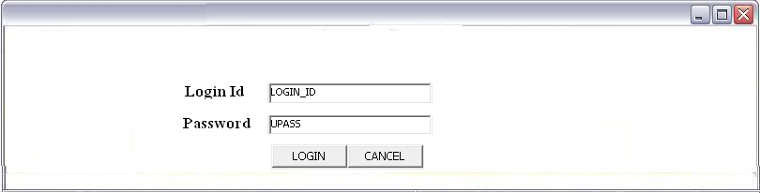
Field Description:
Login name→ To enter the username of the user.
Password→ To enter the password of the user.

Validation:
Login name→ Minimum 1 character and Maximum 12 characters allowed.
Password→ Minimum 6 and maximum 12 characters are required.
If user name found in the record then
-Welcome username
If login name is not found in record then
-User doesn’t exist.
If password is not correct then
-Invalid password

4.11 THE MENUS:

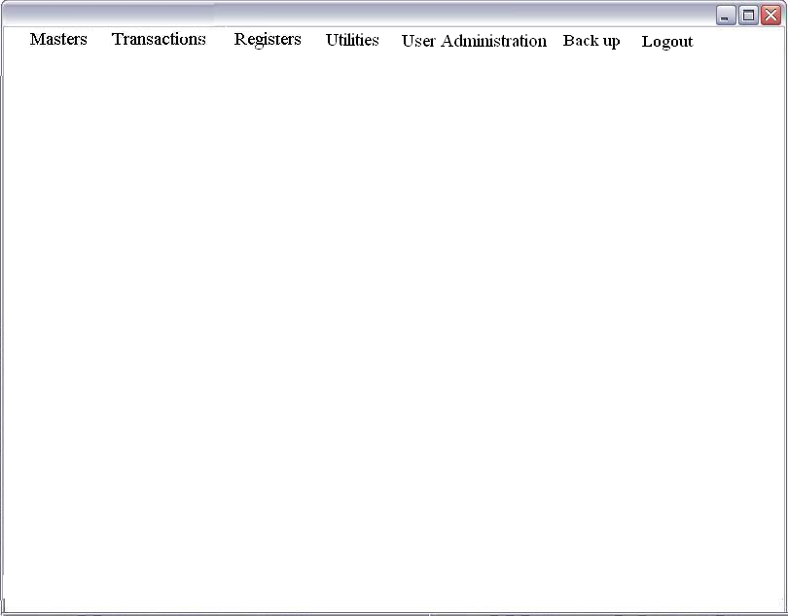

4.12 SHAREHOLDER’S MASTER DATA ENTRY:
The Shareholder’s member data entry screen will appear in the Masters Menu. Through this screen the user will be able to enter all the information of the shareholder.

Menu→
Masters→
Shareholder’s Master Data Entry
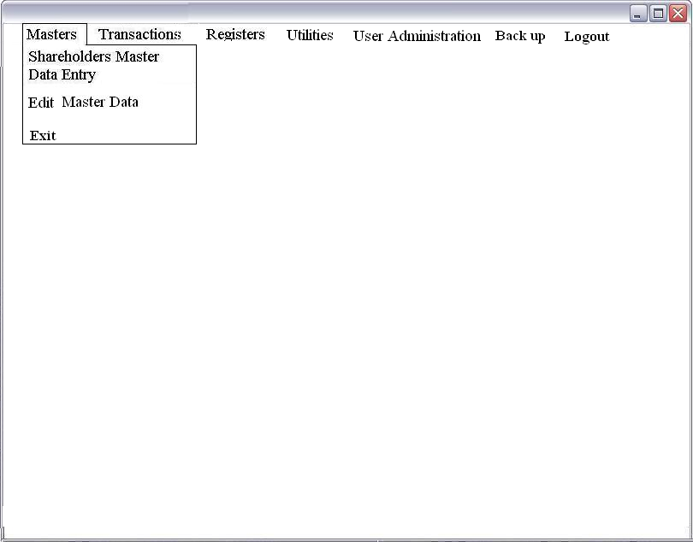

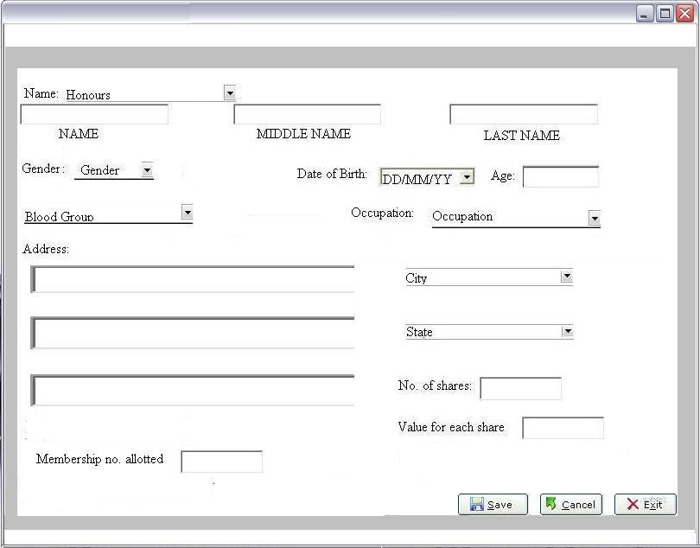
Fields description:
NAME→To enter the first name of the shareholder.
MIDDLE NAME→ To enter the middle name of the shareholder.
LAST NAME→ To enter the surname of the shareholder.
Gender→ To select the gender of the shareholder.
Date→ To enter the date, month & year of birth.
Age→ This will be calculated (in months) according to the date of birth entered.
Blood Group→ To select he blood group of the shareholder.
Address→ Enter the Residential address of the shareholder, excluding the city and state.
No. of shares→ Enter the total number of shares purchased by the shareholder.
Value for each share→ Enter the share value (in Rs.) for each share.

Validation:
Any one out of three fields NAME, MIDDLE NAME & LAST NAME is compulsory.
NAME→ Maximum 20 characters allowed.
MIDDLE NAME→ Maximum 20 characters allowed.
LAST NAME→ Maximum 20 characters allowed.
Address→ Maximum 130 characters allowed.
All the letters in the alphabet A-Z, a-z and all the numerals 0-9 are allowed.
Special symbols such as ? # etc. not allowed.
No. of shares→ This can be maximum a three digit number.
Value for each share→ Share value should be maximum a three digit number

